******Prospect School- December 2023**

**PowerTeacher Attendance Directions**

**Kindergarten Classes only\*\***

**Directions**

1. Go to where you usually take attendance on PowerTeacher. (Quick links- Powerteacher Portal Home)
2. Go to the box next to each student and take attendance as you normally would. You will see these options. (If the child is present you just need to click on the box)

|  |  |
| --- | --- |
| **Present In** | Child is present in school |
| **B (Absence-Unverified)** | Child is absent- there is no letter or doctor’s note sent. |
| **C (Absence-Verified)** | Child is absent- there is a letter or doctor’s note sent. |
| **LEX (Late-Excused)** | Child is late (after 9:00) – there is a letter or doctor’s note sent. (Ms. Davenport will mark.) |
| **LUX (Late- Unexcused)** | Child is late (after 9:00)- there is no letter or doctors note sent. |

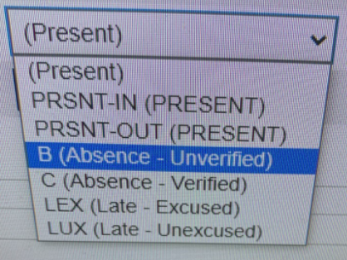

PRSNT-IN (Present)

B (Absence- Unveriffied)

Lex (Late- Excused)

Lux (Late- Unexcused)

1. Take the attendance in homeroom and then press submit.

Press PowerTeacher Pro at the side

1. 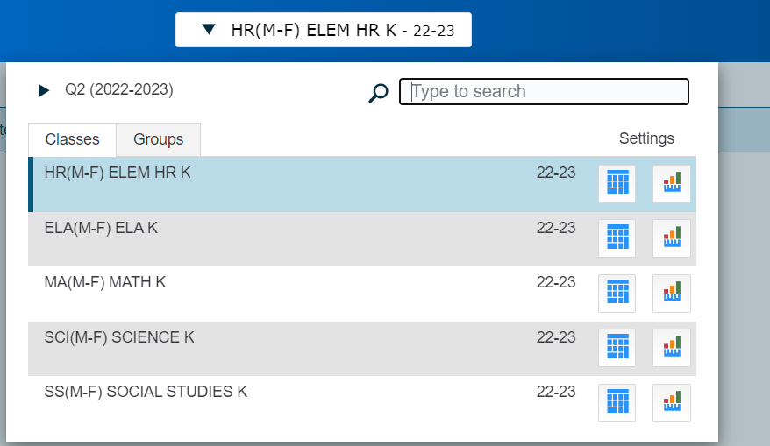Press the top drop down menu and select each subject. Transfer the same attendance onto each subject and press submit at the bottom of the page.. (ELA, Math, Science, Social Studies)

**Power Substitute Directions**

1. Go to [www.hempsteadschools.org](http://www.hempsteadschools.org)
2. Go to teacher/staff
3. Scroll down and click on Power Substitute
4. Select

Language: English

School: Prospect Elementary School

Teacher: (teacher of the class)

Password: Prospect2223

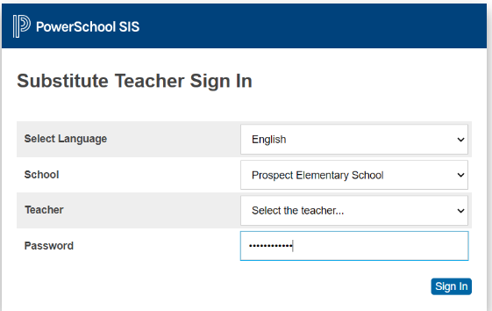



1. Click on the student icon

**Each student needs a mark. After each student is given a mark press submit at the bottom.**

|  |  |
| --- | --- |
| **Present In** | Child is present in school |
| **B (Absence-Unverified)** | Child is absent- there is no letter or doctor’s note sent. |
| **C (Absence-Verified)** | Child is absent- there is a letter or doctor’s note sent. |
| **LEX (Late-Excused)** | Child is late (after 9:00) – there is a letter or doctor’s note sent. (Ms. Davenport will mark.) |
| **LUX (Late- Unexcused)** | Child is late (after 9:00)- there is no letter or doctors note sent. |

**Power Substitute for Special Area Coverage**

1. Go to the Prospect website. Hempsteadschools.org/schools/prospect
2. 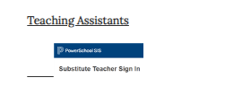Go to teacher/staff tab
3. Scroll down and click on Power Substitute
4. Select

Language: English

School: Prospect Elementary School

Teacher: (special area teacher you are covering for)

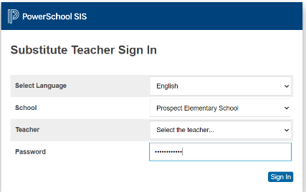Password: Prospect2223

1. 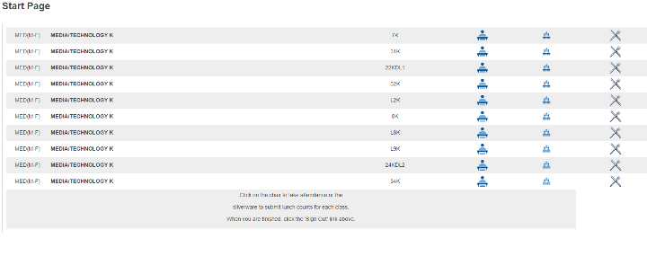Find the room number of the class you are covering.

Click the student next to the room number.

**Each student needs a mark. After each student is given a mark press submit at the bottom.**

**Present in**- student is present and in school

**Present out**- student is present and at home (remote or quarantined- check list from office)